Stock Market Game
Click on the following link
http://www.howthemarketworks.com/contests/find
Register for a free account and join out contest 2015BHSPFQ1 the password is: GOdogs
*** when you register for an account please use: your first name and last initial (SarahR)
Check out the Education center and read about how to pick stocks, the Dogs of the Dow, etc.
You have $100,000 to spend. You must pick at least 5 different stocks and compile a portfolio, answering the following for each:
Look on Yahoo finance and find the following:
Look up Symbol (if you don’t know it you can search for it:
Here’s where you will find information about your stock- read what the analysts say and recent news also:
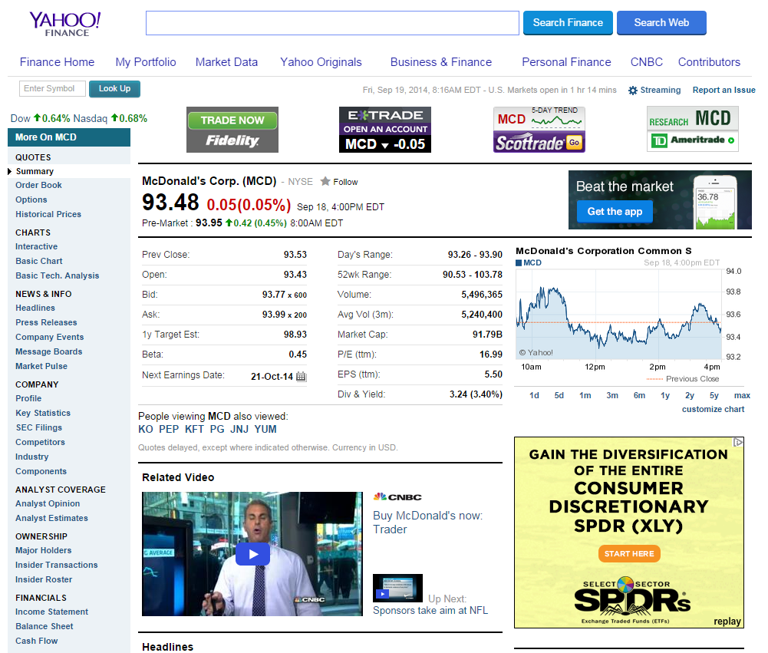
- Allstate Corp.
- ALL
- NYSE
- Car Insurance
- Sells insurance
- $59.70
- $55.00-minimum
- I just picked this one randomly because it looked like it was doing good on the market.

- PepsiCo Inc.
- PEP
- NYSE
- Beverage
- Drinks
- $97.35
- $90.00-minimum
- My parents drink this a lot and so I decided to buy it, plus it is a popular drink.

- Amazon.com Inc.
- AMZN
- NYSE
- Retail
- Sells anything for a cheaper price
- $550.713
- $550.00-minimum
- I have used this before and I know that a lot of people use this industry.

- Netflix Inc.
- NFLX
- NYSE
- Entertainment
- Allows for you to watch movies/TV shows
- $110.795
- $110.00- minimum
- I have watched movie/tv shows on there before and a lot of young people use it constantly.

- Facebook Inc.
- FB
- NYSE
- Social media
- Allows you to connect to people
- $93.96
- 90.00-minimum
- I used Facebook when I was younger and I still do occasionally.

When Complete please upload to your website. Be sure to label the paper and the file with your name.

