Budget Assignment
Based on your career choice and the state in which you chose to live after college, create a realistic budget using the “Zero Budget” system. List your income for the year and break it down by the month (net monthly income). Be sure to look up costs and find realistic figures and spend down to zero. Taxes will take away 18% of your gross monthly income. Use the table below and add extra rows, listing all items and how you will spend your money. Figure the % of your net income keeping between the recommended percentages listed in the presentation. Make sure to use the last two slides of the presentation to make sure you account for all expenses you may incur. Use the resource column to site or explain how you got the information you received. Make sure your total matches what you have to spend. Below your budget include a picture or the house or apartment and vehicle (if necessary) you found with all information about the cost.
Career, State | Salary | Salary After Taxes | Monthly Budget
Marine Biologist, Florida | $37,600 | $30,832 | $2,569
Item | Cost | % of Net Income | Resource
Apartment  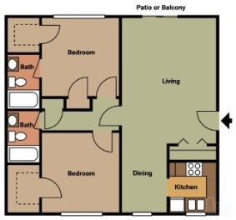 | $715/month  (shared=$357.50/month) | 13.9% | www.rent.com  (shared with another person)
Renters Insurance | $10/month | 0.4%
Utilities | Part of rent |  | Utilities is part of the rent in this apartment
Car Insurance | $70/month | 2.7% | My Mom gave me the info.
Health Insurance | $100/month | 3.9%
Student Loan | $447.30/month | 17.4%
Savings | $256.90/month | 10%
Phone | $30/month | 1.2% | My Mom gave me the info.
Entertainment | $200/month | 7.8% | Movies, concert, etc.
Food | $200/month | 7.8% | HyVee.com  (tend to spend $100 every two weeks on food)
Clothing | $100/month | 3.9% | Anything needed that has to do with clothes
Personal | $250/month | 9.7% | Haircut, make-up, etc.
Dog | $250/month | 9.7% | Dog shampoo, haircut, dog food, etc.
Money Left Over | $447.30 | 17.4% | This money can be used in savings, entertainment, etc.
Total | $2,569 | 100%

